Docker Task -03

Overall Task Title
End-to-End Docker, Image Management, Security Scanning, and Jenkins CI/CD Pipeline Implementation
Objective
The objective of this task was to gain hands-on experience with Docker image creation, optimization, distribution, security scanning, and CI/CD automation.
This included creating images from running containers, transferring images across systems, building optimized Docker images using Alpine and multi-stage builds, executing applications using Docker Compose, implementing image vulnerability scanning, and automating image build-and-push workflows using Jenkins.
Prerequisites
- Linux-based servers (Amazon Linux / Ubuntu)
- Docker installed and running
- Docker Hub account
- AWS account with Amazon ECR access
- Jenkins installed and configured
- Git installed
- Basic knowledge of:
  - Docker & Dockerfiles
  - Jenkins pipelines
  - Git & GitHub
  - AWS ECR
  - Container security concepts

Create a image from running container.
- Pull nginx image
- Use command: docker pull nginx
- It already exist
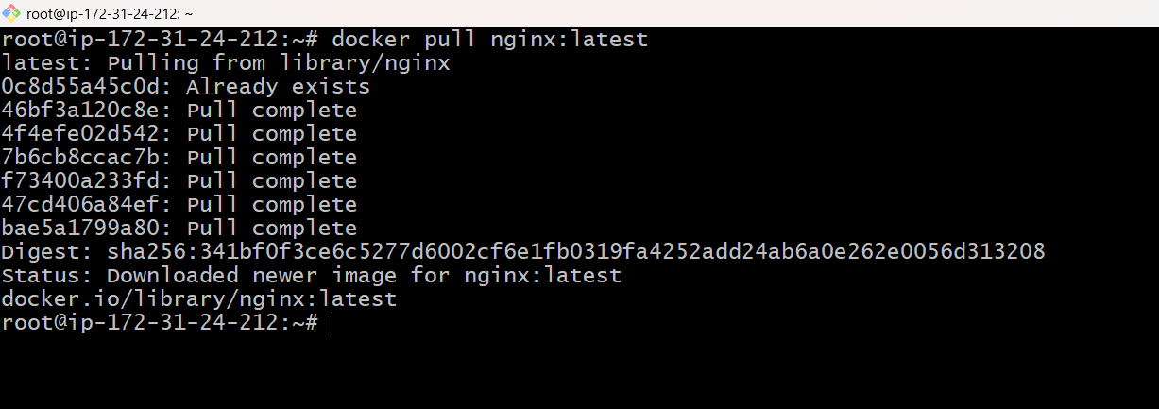
- Run nginx container
Use command: docker container run -itd -p 81:80 –name nginx-container nginx:latest
- Verified container using command: docker ps
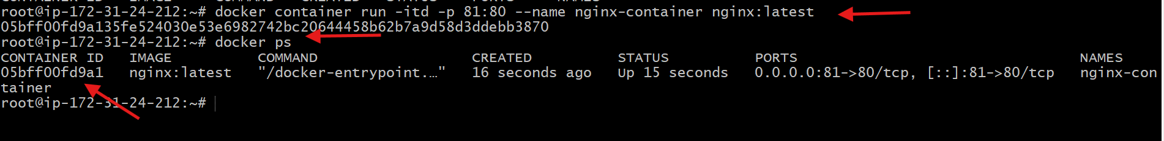
- Entered running container
use command: docker exec -it nginx-container /bin/bash
- Changed the content in index.html
- Created image for container use command: docker commit nginx-container custom-nginx:v1
- Image has been created successfully
- Verified image using command: docker images
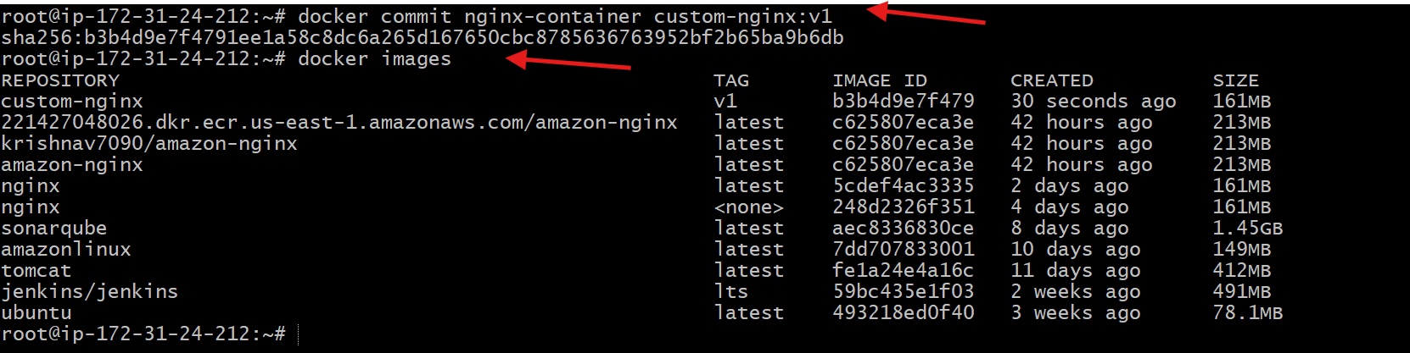
- Now using public Ip of ec2 verify in browser
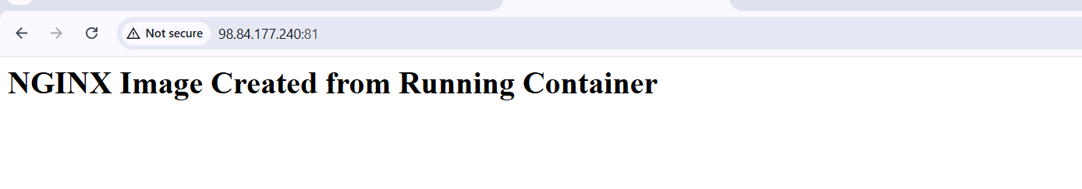
2. Copy image from local machine to docker server and load the image.
Steps performed:
- Logged in to Docker Hub
Command: docker login
- Pulled nginx image on local machine
Command: docker pull nginx:latest
- Verified nginx image locally
Command: docker images
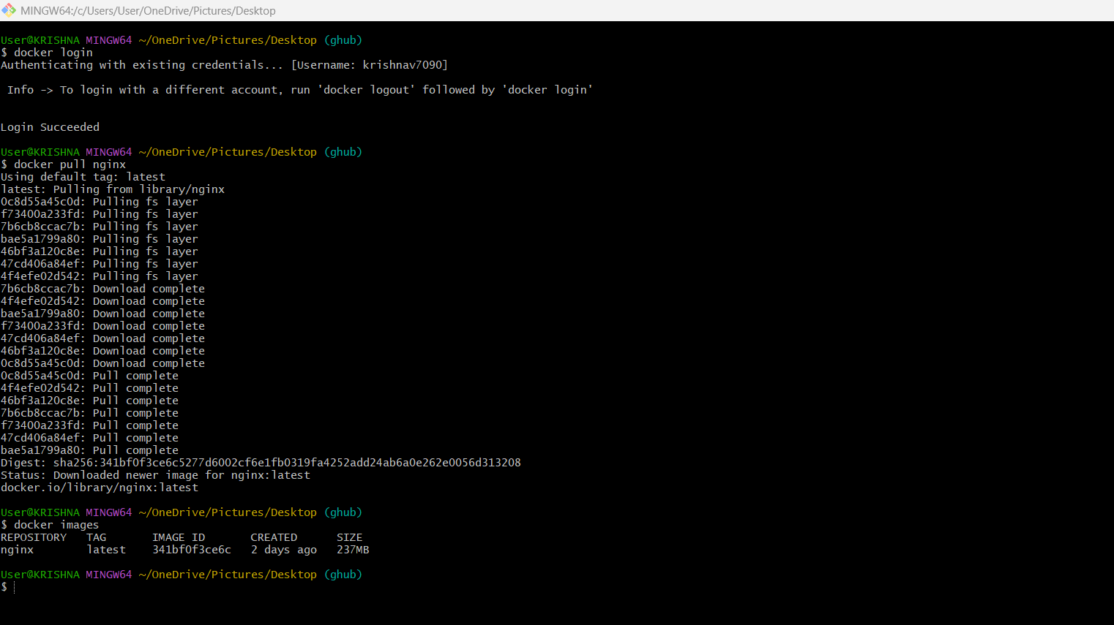
- Saved nginx image to tar file on local machine
Command: docker save nginx: latest -o nginx.tar
- Verified tar file creation
Command: ls -lh nginx.tar
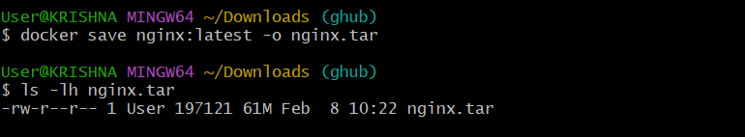
- Copied nginx image tar from local machine to remote Ubuntu EC2
Command: scp -i NV.pem nginx.tar ubuntu@18.206.211.243:/home/ubuntu/
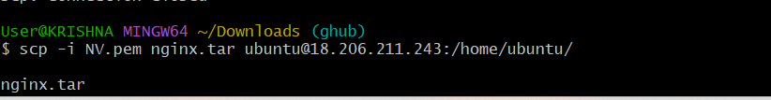
- Logged in to remote Ubuntu EC2 server
Command: ssh -i NV.pem ubuntu@18.206.211.243
- Verified nginx.tar file on EC2
Command: ls
- Loaded nginx image into Docker on EC2
Command: sudo docker load -i /home/ubuntu/nginx.tar
- Verified nginx image on EC2
Command: sudo docker images
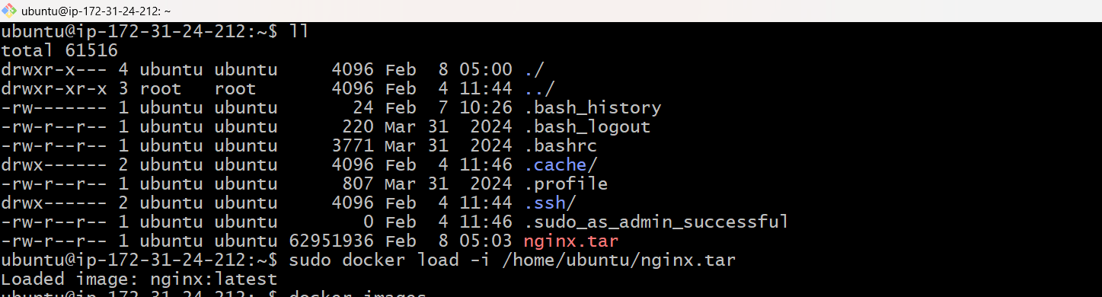

3. Create Docker image using alpine and customize with tomcat.
Steps performed:
- Created a project directory
Command: mkdir alpine-tomcat
- Moved into the project directory
Command: cd alpine-tomcat
- Created and edited the Dockerfile
Command: vi Dockerfile
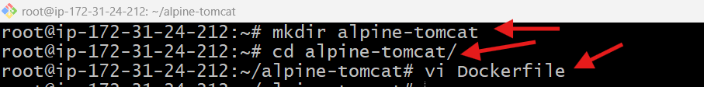
4.Added Alpine + Tomcat Dockerfile content and saved it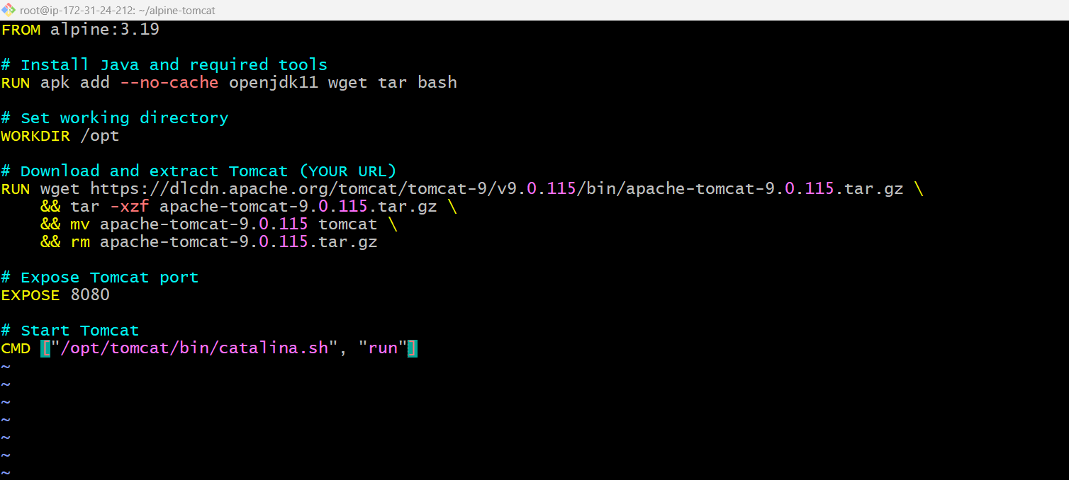
- Built the Docker image from the Dockerfile
Command: docker build -t alpine-tomcat:latest .
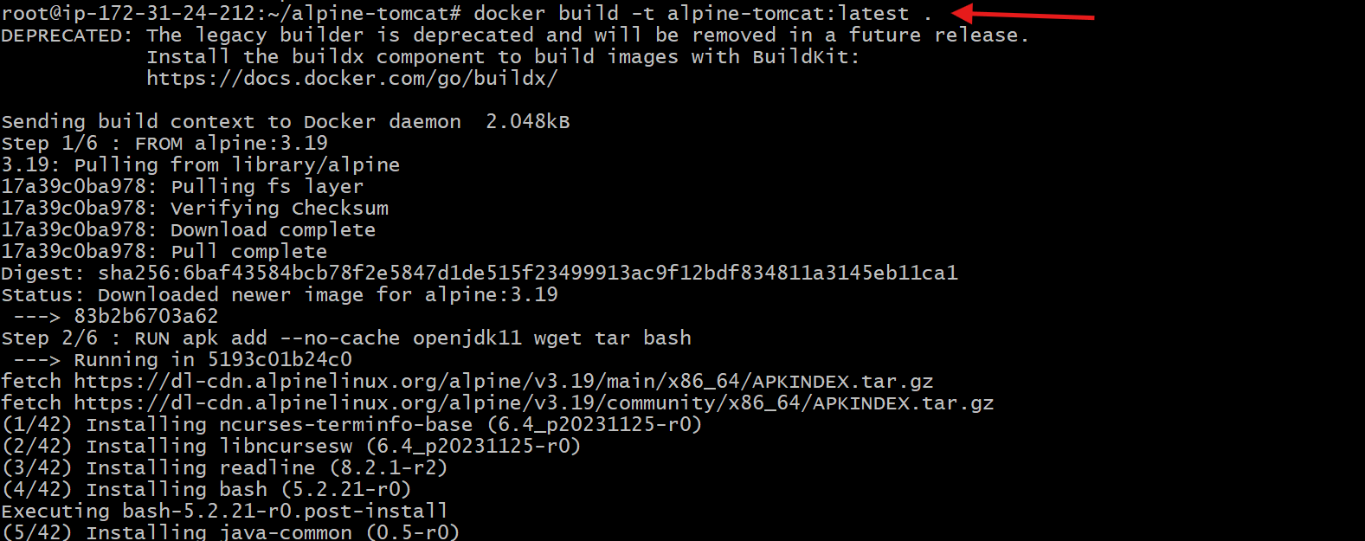
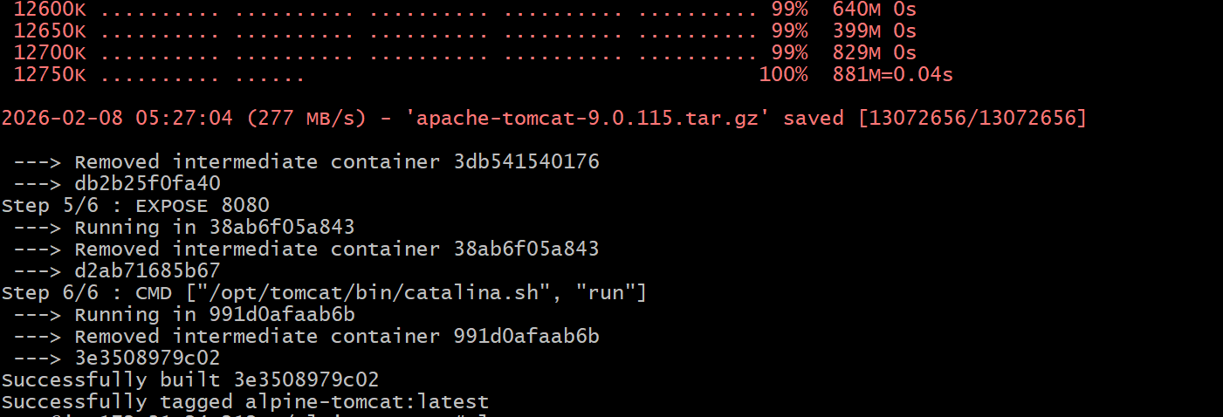
- Verified the Docker image was created
Command: docker images
- Ran the Tomcat container with port mapping and container name
Command: docker run -d -p 8080:8080 --name tomcat alpine-tomcat:latest
- Verified the running container
Command: docker ps
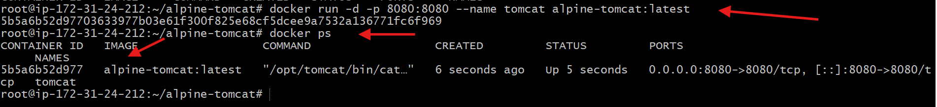
- Accessed Tomcat application in browser
Browse: http://18.206.211.243:8080
- Confirmed Apache Tomcat 9.0.115 home page loaded successfully
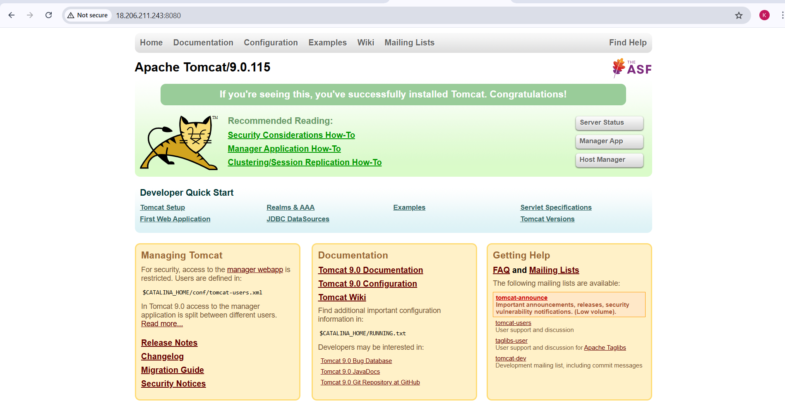

- Create single stage and multi stage docker file using this source code: https://github.com/betawins/multi-stage-example.git
Steps performed:
- Git clone the repo
Command: git clone https://github.com/betawins/multi-stage-example.git
- Verfiy the files
Command: ll
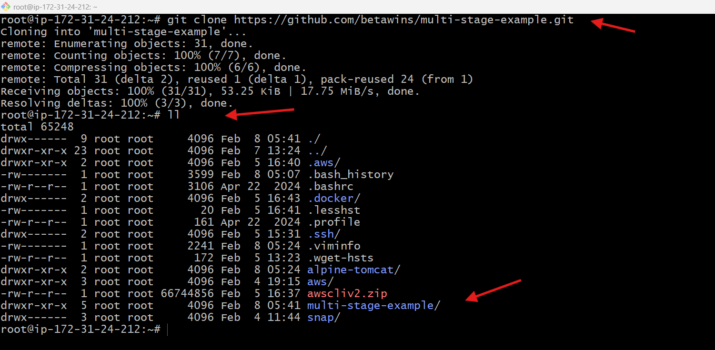
- Cd to multi_stage-example file
- Verify the files inside multi_stage-example
Command: ls
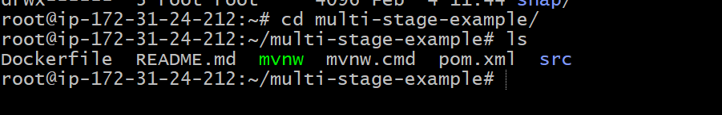
PART 1: Single-Stage Dockerfile – Steps Performed
- Cloned the source code repository
git clone https://github.com/betawins/multi-stage-example.git
- Navigated to the project directory
cd multi-stage-example
- Created and edited the Dockerfile
vi Dockerfile
- Added single-stage Dockerfile content (Maven build + run in same image)
- Verified Dockerfile content
cat Dockerfile
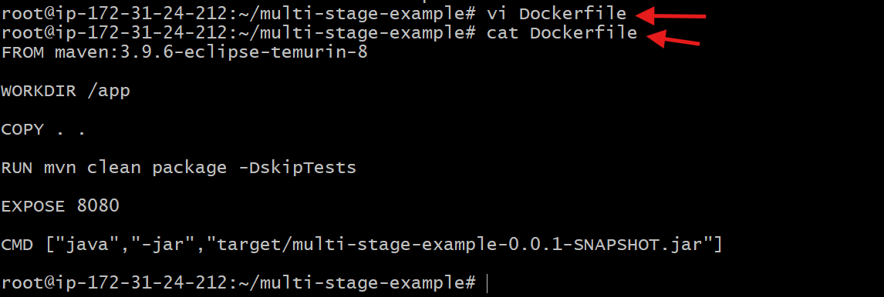
- Built the single-stage Docker image
docker build -t single-stage:v1 .
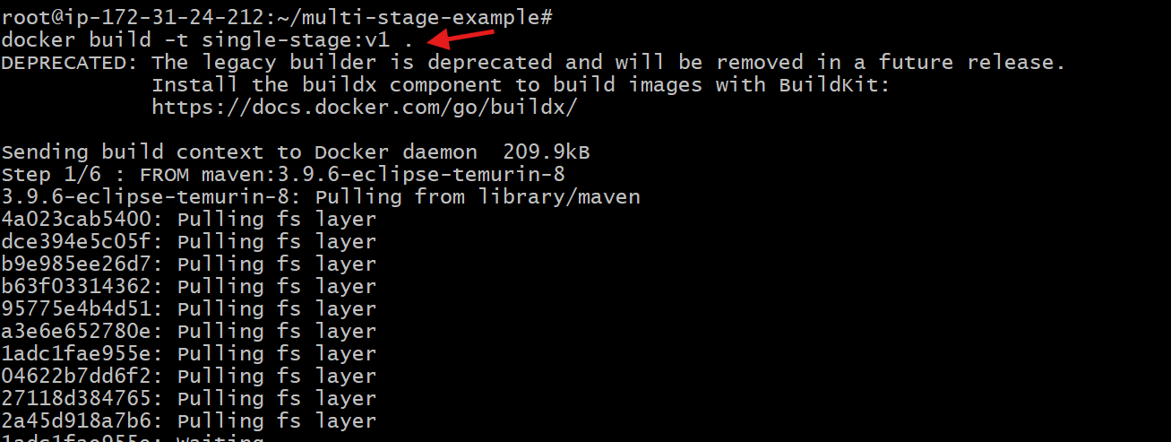
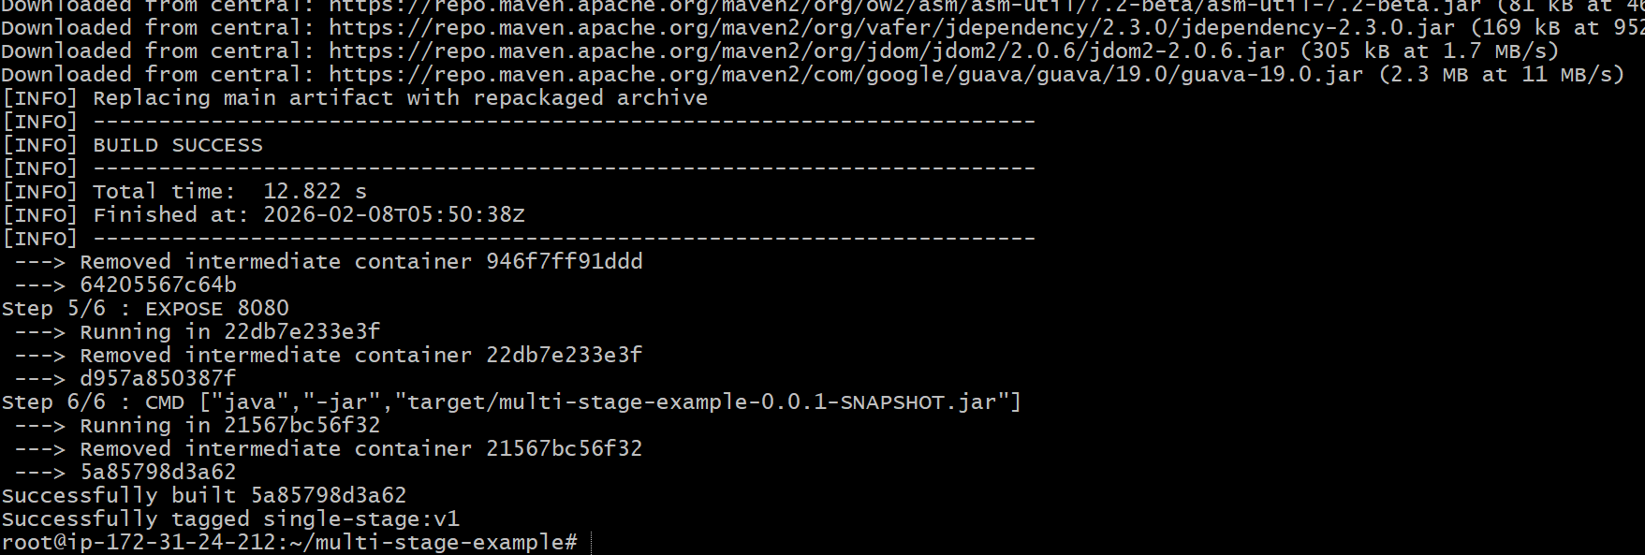
- Verified the Docker image creation
docker images
- Ran the single-stage application container with port mapping
docker run -d -p 8081:8080 single-stage:v1
- Verified the running container
docker ps
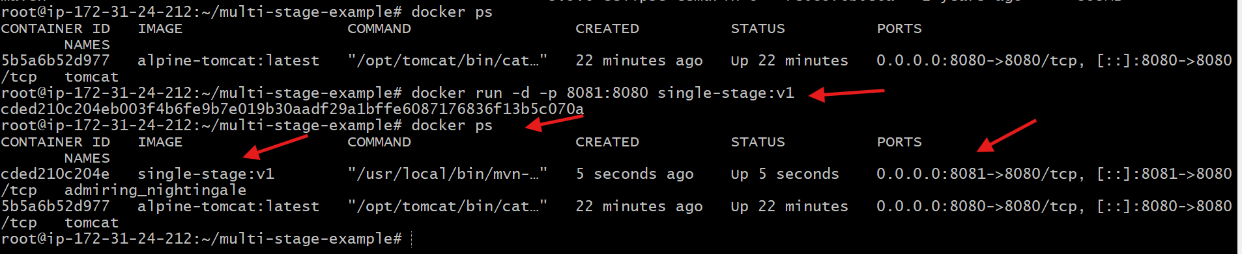
- Accessed the application from browser
Browse: http://18.206.211.243:8081
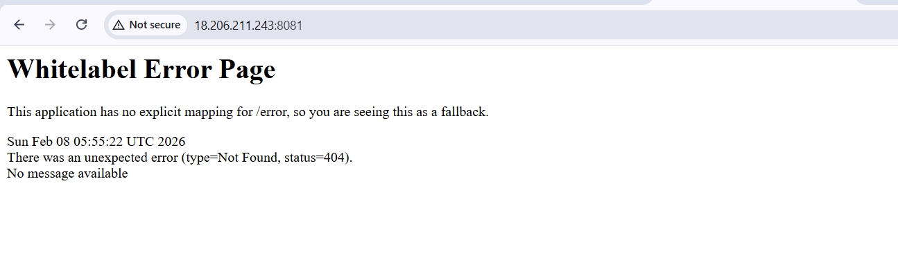

PART 2: Multi-Stage Dockerfile – Steps Performed
- Opened the project directory
cd multi-stage-example
- Edited the Dockerfile for multi-stage build
vi Dockerfile
- Added multi-stage Dockerfile with build stage and run stage
- Verified Dockerfile content
cat Dockerfile
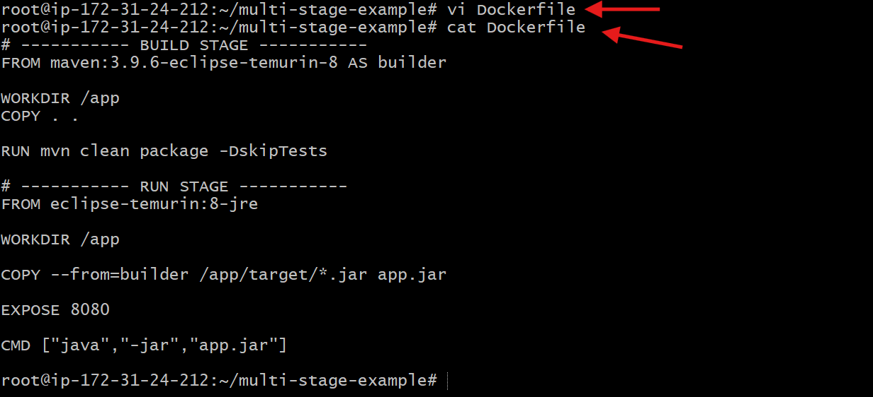
- Built the multi-stage Docker image
docker build -t multi-stage:v1 .
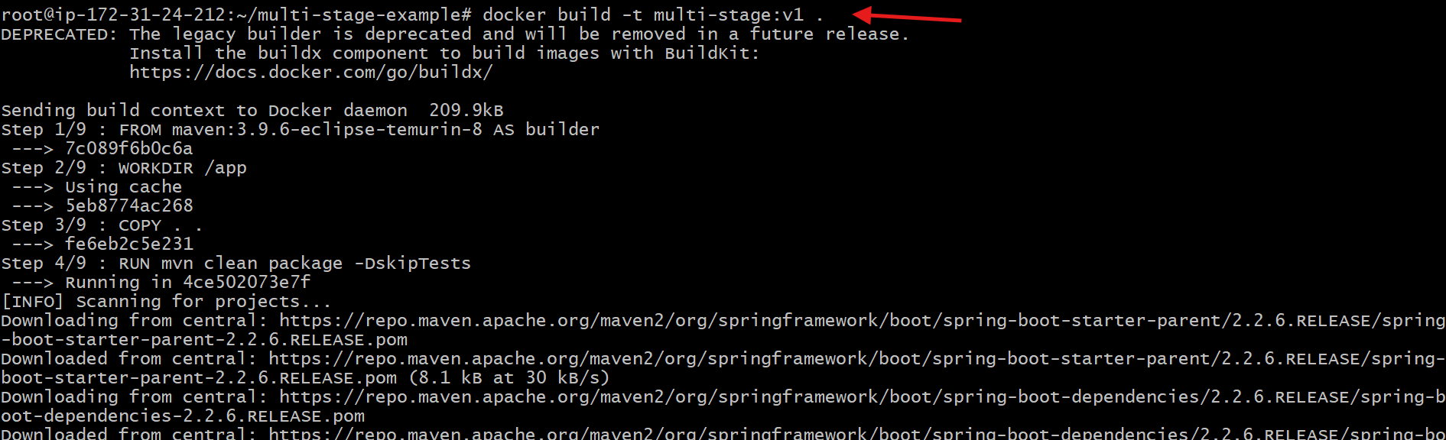
- Verified the multi-stage image creation
docker images
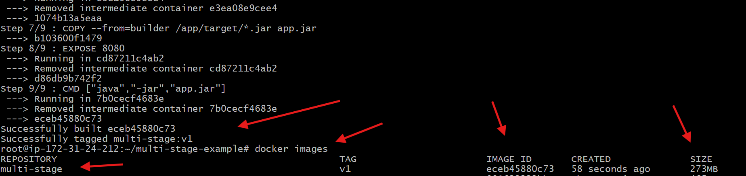
- Ran the multi-stage container with port mapping
docker run -d -p 8082:8080 multi-stage:v1
- Verified the running container
docker ps
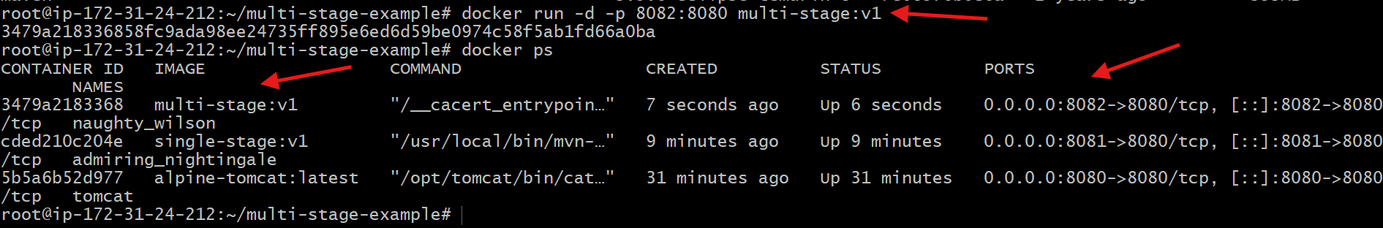
- Accessed the application from browser
Browse: http://18.206.211.243:8082

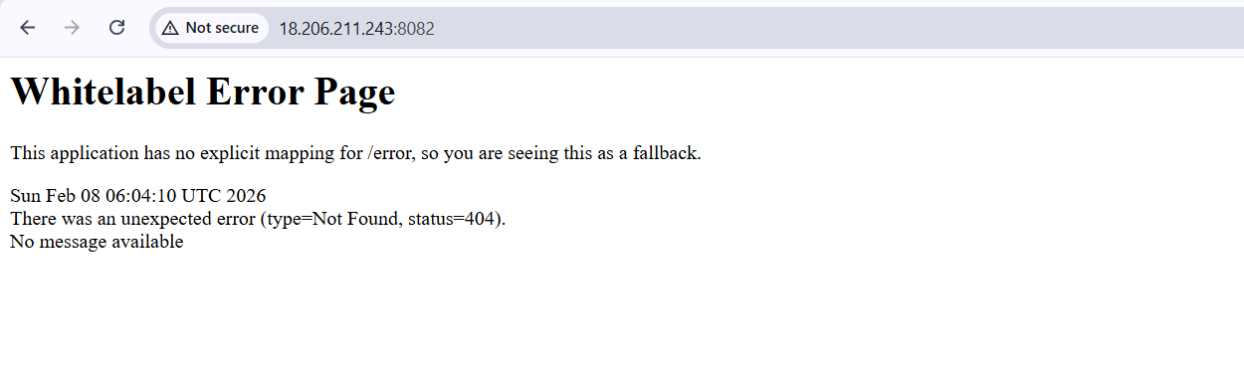
Feature | Single-Stage Dockerfile | Multi-Stage Dockerfile
Base image | Maven image (build + run together) | Maven (build) + JRE (run)
Build tools in final image | Present (Maven, source code) | Removed
Image size | Large (~465 MB) | Smaller (~273 MB)
Security | Less secure | More secure
Best for | Learning, testing | Production
Build time | Slightly faster | Slightly slower
Runtime efficiency | Lower | Higher

- Install docker compose and execute sample application.
Steps performed:
- Checked Docker version
docker --version

- Downloaded Docker Compose binary
sudo curl -L https://github.com/docker/compose/releases/latest/download/docker-compose-linux-x86_64 \
-o /usr/local/bin/docker-compose
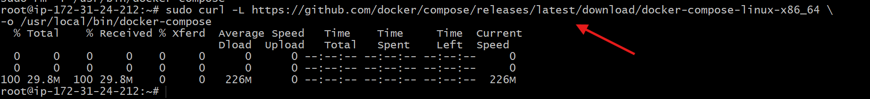
- Gave execute permission to Docker Compose
sudo chmod +x /usr/local/bin/docker-compose
- Created symbolic link for Docker Compose
sudo ln -s /usr/local/bin/docker-compose /usr/bin/docker-compose
- Verified Docker Compose installation
docker-compose --version
- Created Docker Compose configuration file
vi docker-compose.yml
- Added nginx service configuration and saved the file
- Verified docker-compose file content
cat docker-compose.yml
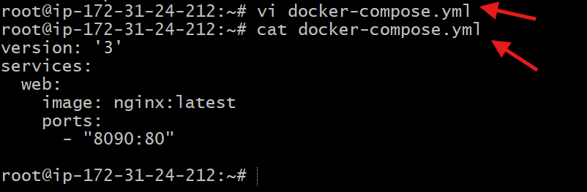
- Started application using Docker Compose
docker-compose up -d
- Verified running services using Docker Compose
docker-compose ps
- Verified running containers
docker ps
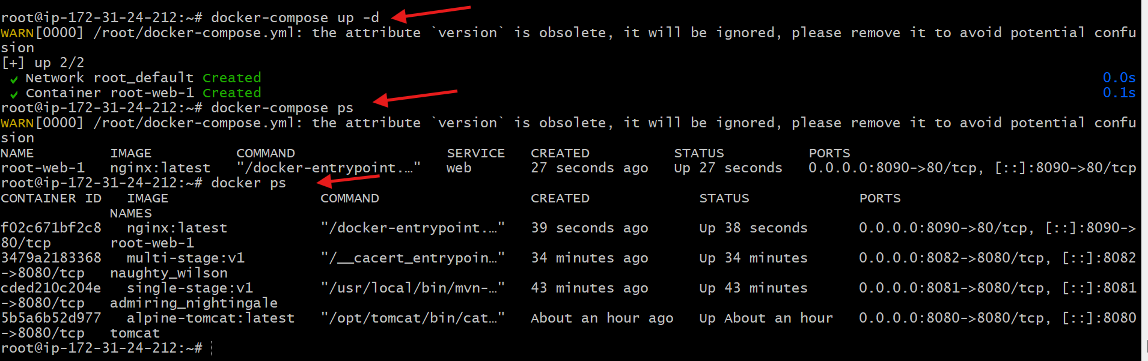
- Tested application locally using curl
curl http://localhost:8090

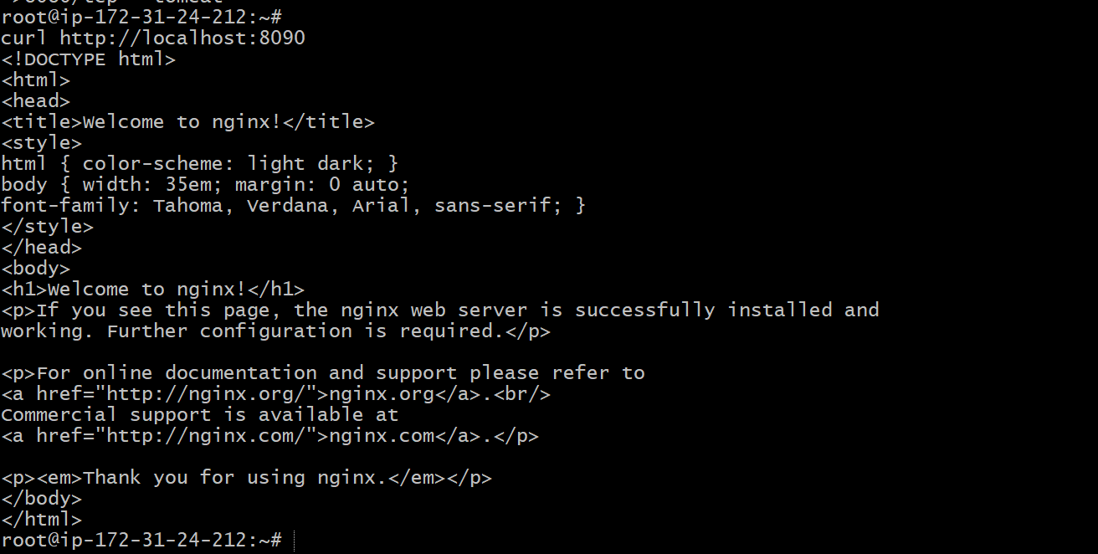
- Accessed application from browser
http://18.206.211.243:8090
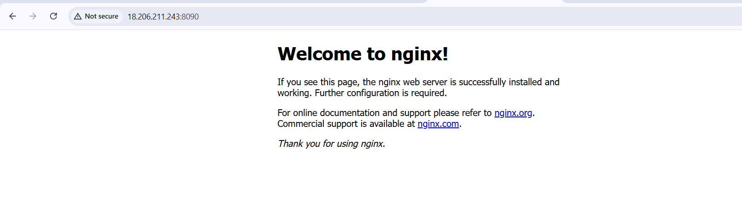

- Implement solution to scan images when pushed to docker registry.
Steps performed:
- Opened Docker Hub repository settings for krishnav7090/amazon-nginx
- Enabled Docker Scout image analysis in repository settings and saved changes
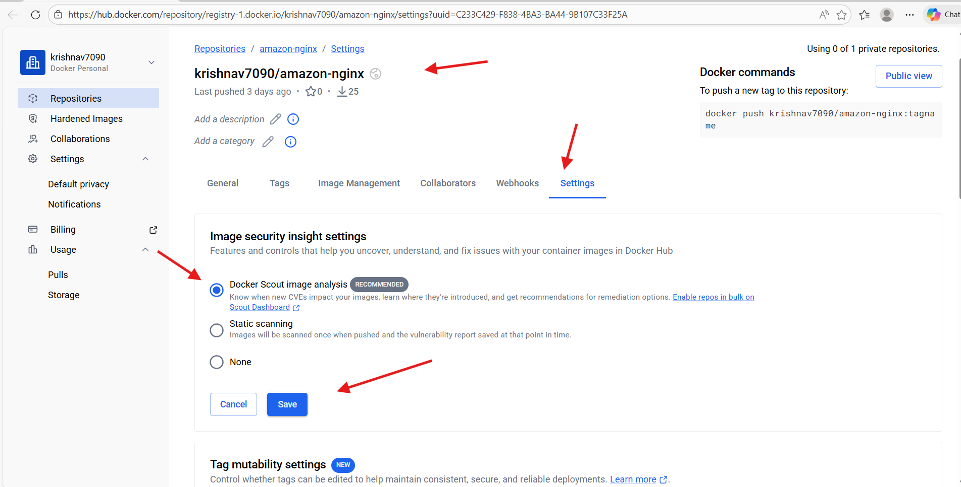
- Logged in to Docker Hub from Docker server
docker login
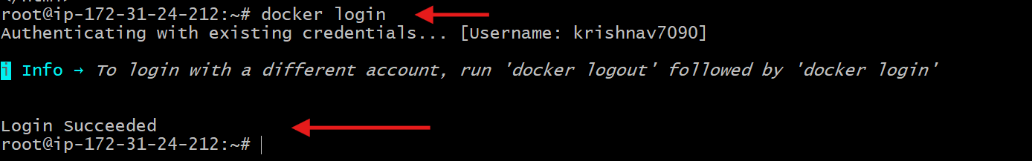
- Tagged the local Docker image for Docker Hub repository
docker tag multi-stage:v1 krishnav7090/amazon-nginx:v1
- Verified the tagged image locally
docker images
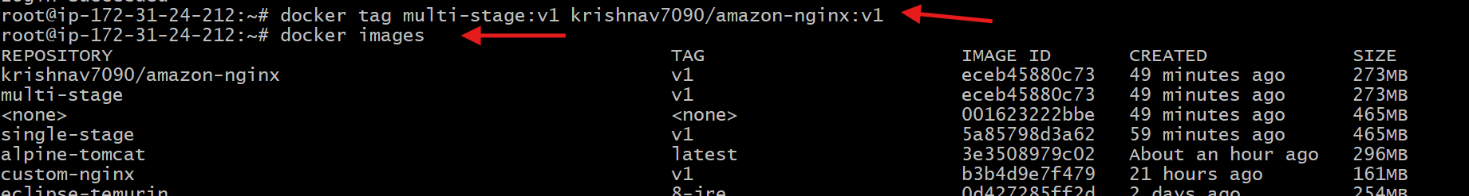
- Pushed the image to Docker Hub repository
docker push krishnav7090/amazon-nginx:v1
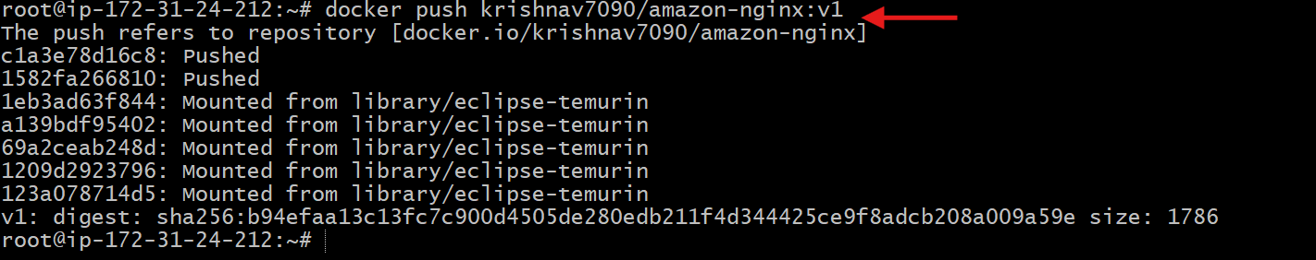
- Verified successful image push (digest displayed in terminal)
- Opened Docker Hub and verified the image krishnav7090/amazon-nginx: v1 appeared under Images
- Viewed image layers and vulnerability scan results in Docker Hub
- Confirmed image details such as base image, exposed port, CMD, size, and CVE list displayed successfully
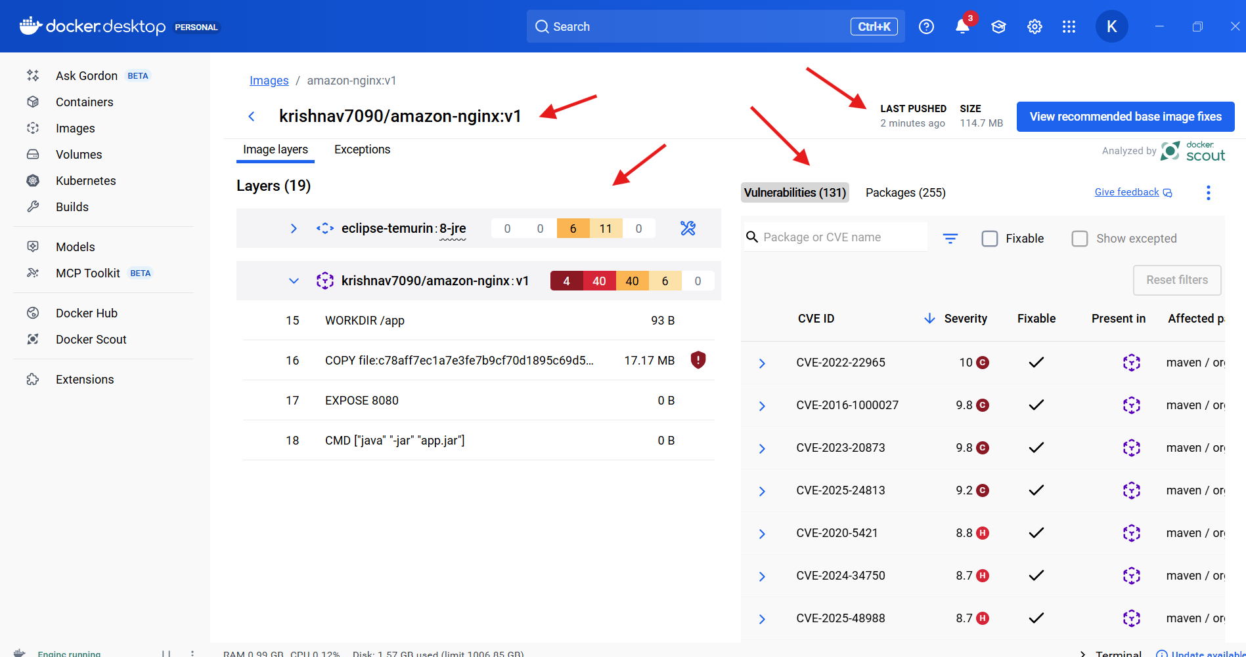

- Implement solution to scan images when pushed to AWS ECR.
Steps performed:
- Created an Amazon ECR repository in us-east-1
aws ecr create-repository \
--repository-name my-ecr-repo \
--region us-east-1
- Verified repository details and observed scanOnPush was false
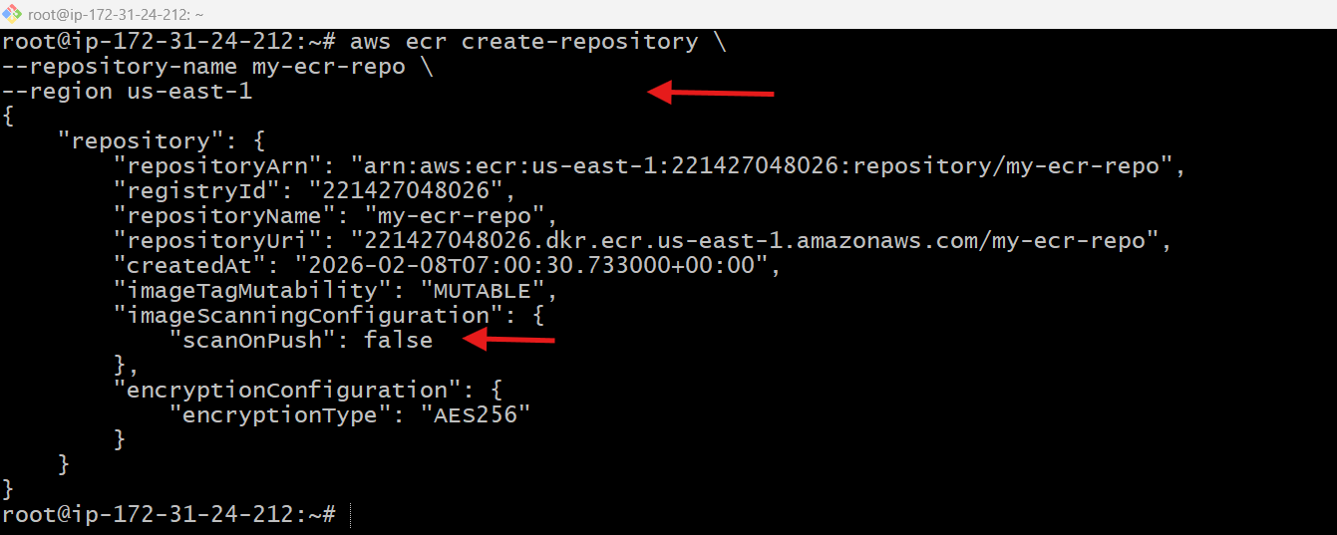
- Enabled image scan on push for the ECR repository
aws ecr put-image-scanning-configuration \
--repository-name my-ecr-repo \
--image-scanning-configuration scanOnPush=true \
--region us-east-1
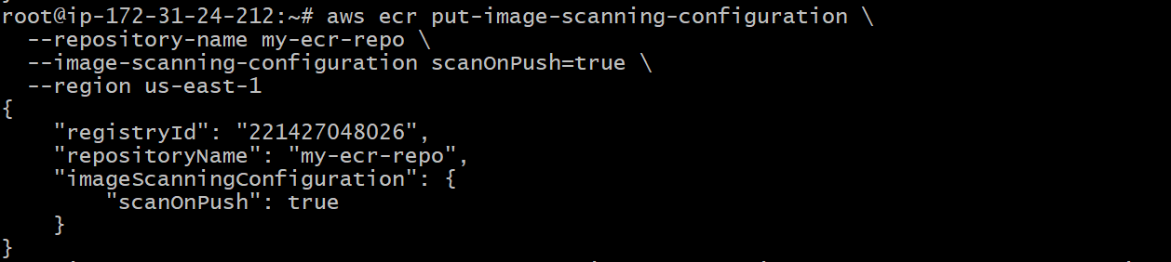
- Logged in to Amazon ECR using AWS CLI
aws ecr get-login-password --region us-east-1 \
| docker login --username AWS --password-stdin 221427048026.dkr.ecr.us-east-1.amazonaws.com
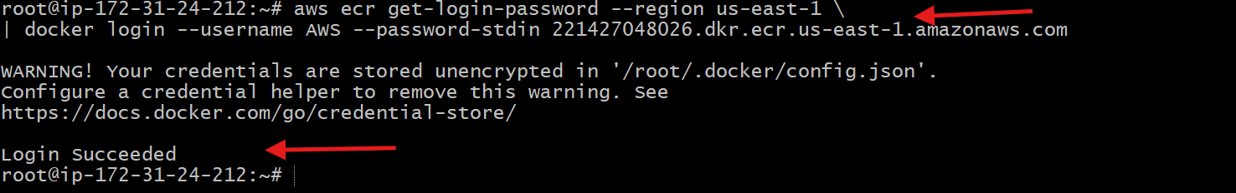
- Tagged the local Docker image for ECR
docker tag multi-stage:v1 \221427048026.dkr.ecr.us-east-1.amazonaws.com/my-ecr-repo:v1
- Verified the tagged image locally
docker images
- Pushed the Docker image to Amazon ECR
docker push 221427048026.dkr.ecr.us-east-1.amazonaws.com/my-ecr-repo:v1
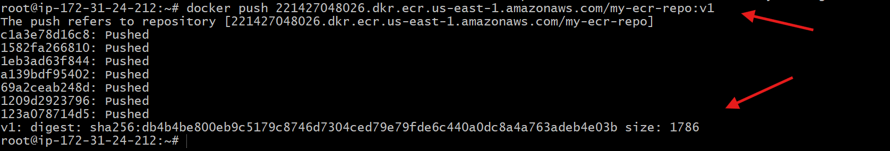
8. Verified image availability in the ECR repository (AWS Console → Images tab)
9. Opened image details in ECR and confirmed scan completed successfully

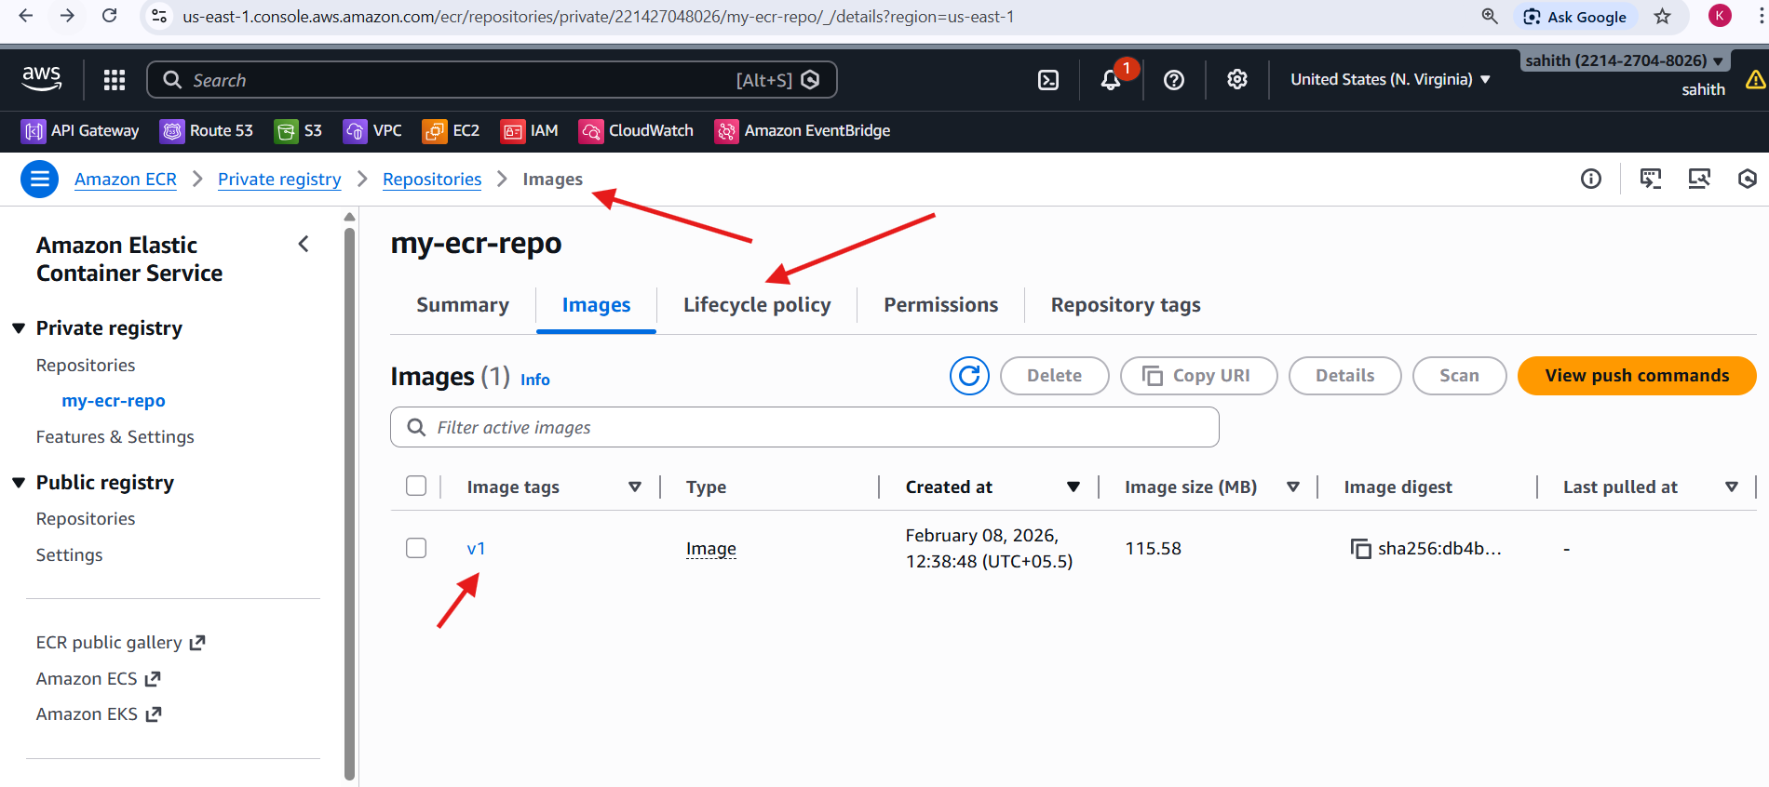
10. Verified vulnerability scan results showed 0 Critical, 0 High, 0 Medium, 0 Low, 0 Info
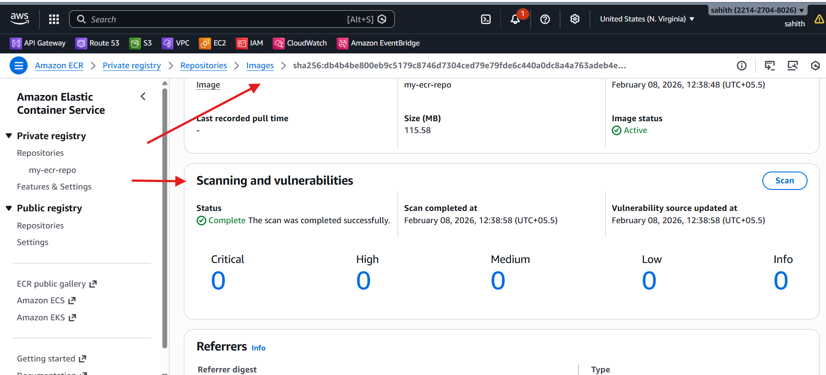

- Create a Jenkins pipeline to create a docker image and push the image to Docker hub.
Steps Performed:
1. Jenkins Server Preparation
- Launched an EC2 instance (Amazon Linux 2023) for Jenkins.
- Installed Java 17 (Amazon Corretto).
- Installed Jenkins and started the service on port 8080.
- Fixed startup issues caused by:
  - Low disk space (/var/lib/jenkins cleanup)
  - Removed old workspaces, builds, Sonar cache, Terraform cache
- Verified Jenkins UI accessibility on:
- http://<EC2-IP>:8080
2. Docker Installation on Jenkins Server
- Installed Docker using dnf (Amazon Linux package manager).
- Started and enabled Docker service:
- systemctl start docker
- systemctl enable docker
- Added Jenkins user to Docker group:
- usermod -aG docker jenkins
- Restarted Jenkins to apply Docker group permissions.
- Verified Docker access as Jenkins user:
- sudo -u jenkins docker ps

3. Jenkins Plugin Installation
Installed required plugins from Manage Jenkins → Plugins:
- Docker
- Docker Commons
- Docker Pipeline
- Git
- Pipeline
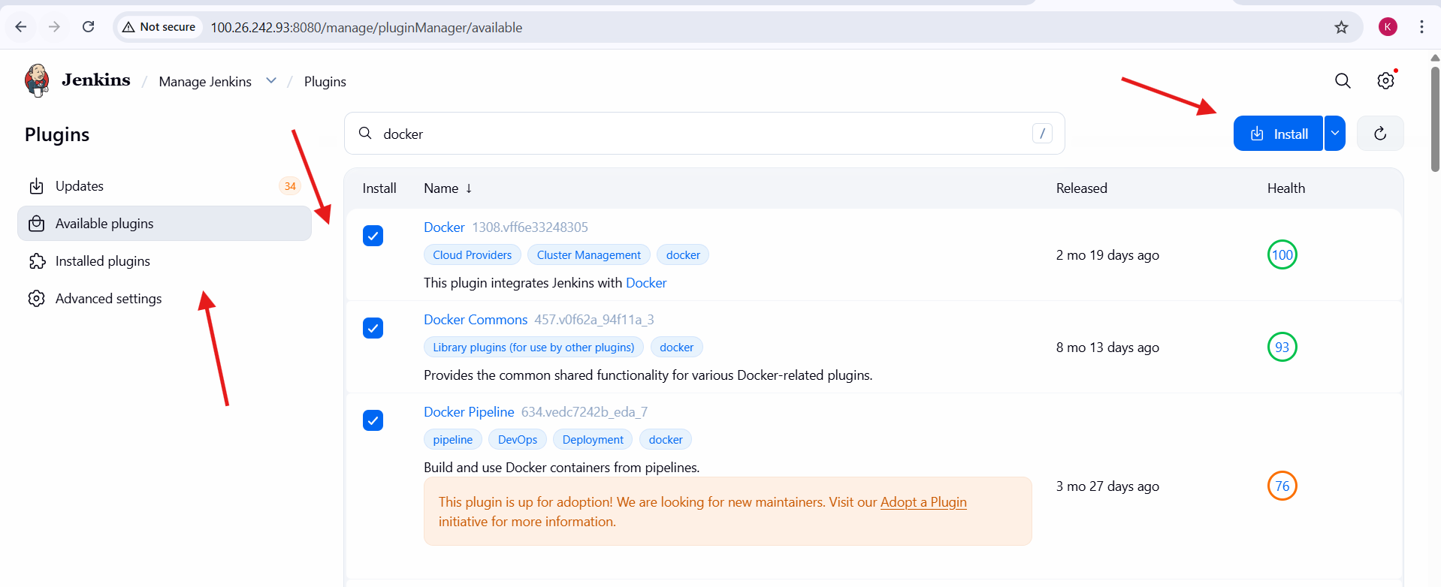
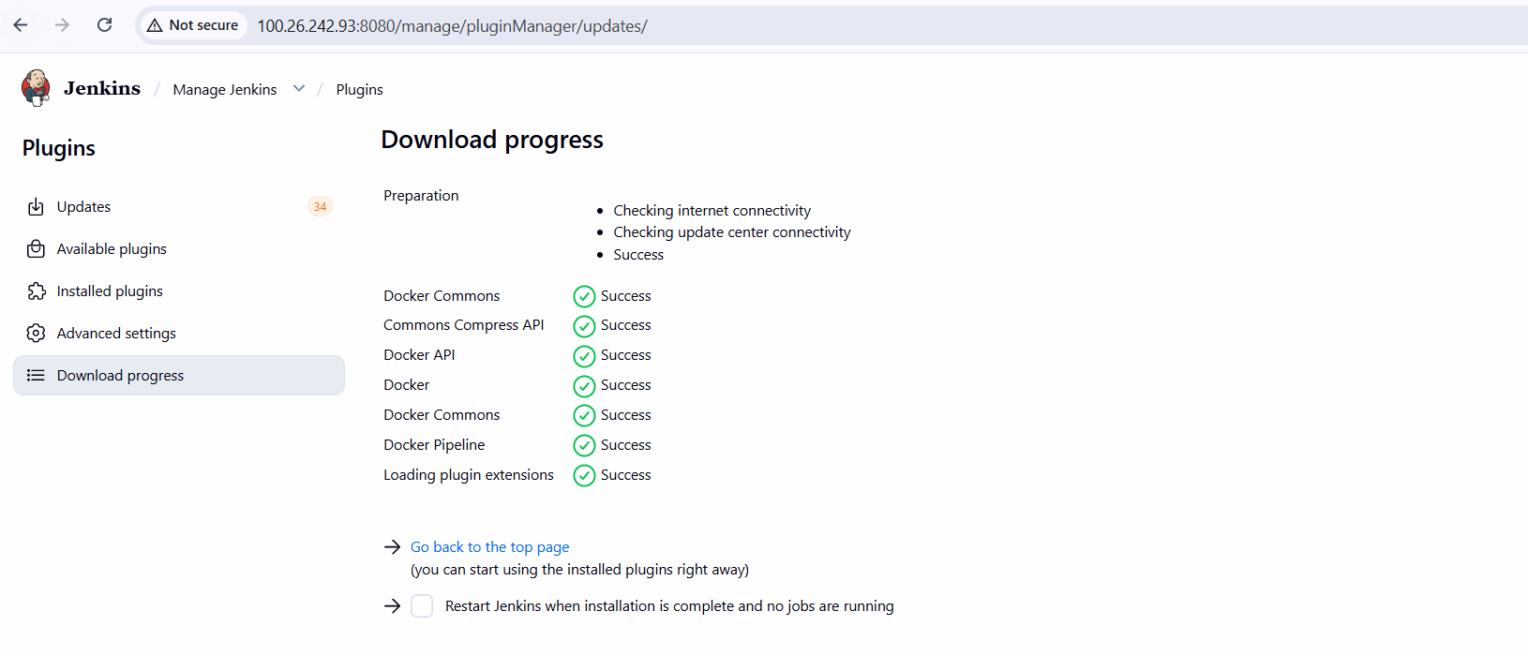
4. Docker Hub Credentials Configuration
- Navigated to:
- Manage Jenkins → Credentials → System → Global Credentials
- Added credentials:
  - ID: Docker
  - Type: Username with password
  - Username: Docker Hub username
  - Password: Docker Hub password
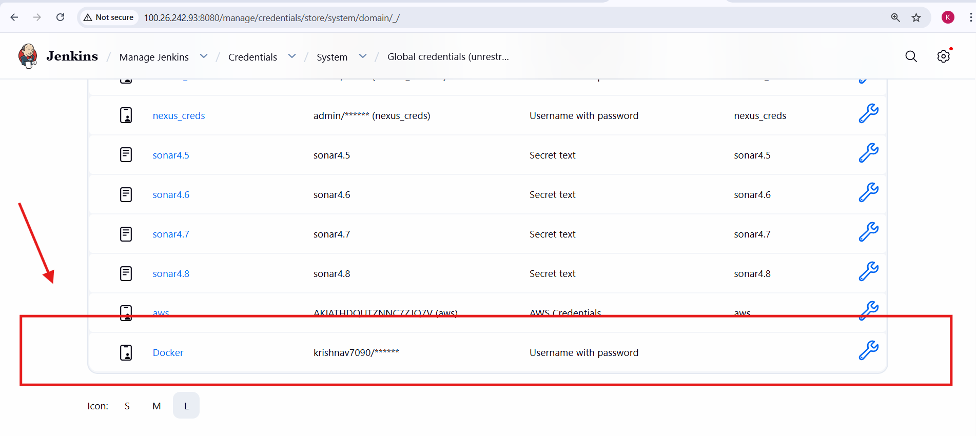
5. GitHub Repository Setup
- Created GitHub repository:
- https://github.com/krishnav7090/Docker-pipeline
- Added the following files:
Dockerfile
FROM nginx:latest
COPY index.html /usr/share/nginx/html/index.html
index.html
<h1>Jenkins CI/CD Success</h1>
<p>This application was built, containerized, and pushed using Jenkins.</p>
Jenkinsfile
- Defined pipeline stages:
  - Checkout Code
  - Build Docker Image
  - Docker Hub Login
  - Push Image to Docker Hub
Script:
pipeline {
agent any

environment {
IMAGE_NAME = "krishnav7090/myapp"
IMAGE_TAG = "v1"
DOCKERHUB_CREDS = "Docker"
}

stages {

stage("Checkout Code") {
steps {
checkout scm
}
}

stage("Build Docker Image") {
steps {
sh "docker build -t ${IMAGE_NAME}:${IMAGE_TAG} ."
}
}

stage("Docker Hub Login") {
steps {
withCredentials([usernamePassword(
credentialsId: DOCKERHUB_CREDS,
usernameVariable: 'DOCKER_USER',
passwordVariable: 'DOCKER_PASS'
)]) {
sh 'echo "$DOCKER_PASS" | docker login -u "$DOCKER_USER" --password-stdin'
}
}
}

stage("Push Image to Docker Hub") {
steps {
sh "docker push ${IMAGE_NAME}:${IMAGE_TAG}"
}
}
}

post {
success {
echo "Image successfully pushed to Docker Hub"
}
failure {
echo " Pipeline failed"
}
}
}
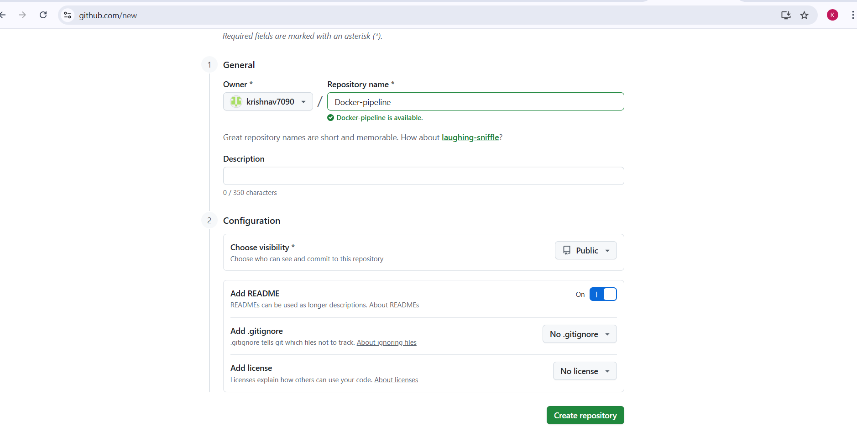
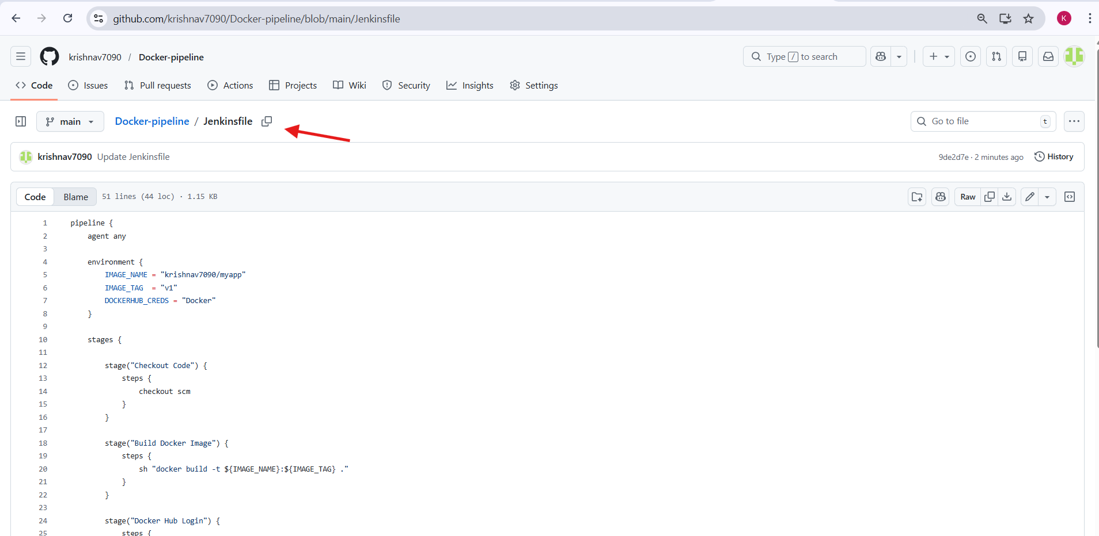
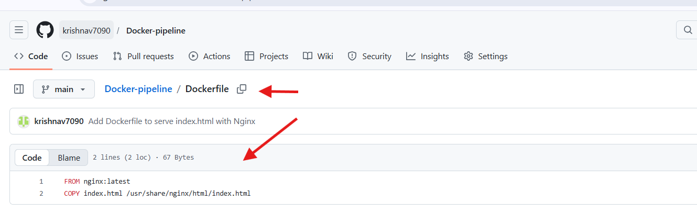
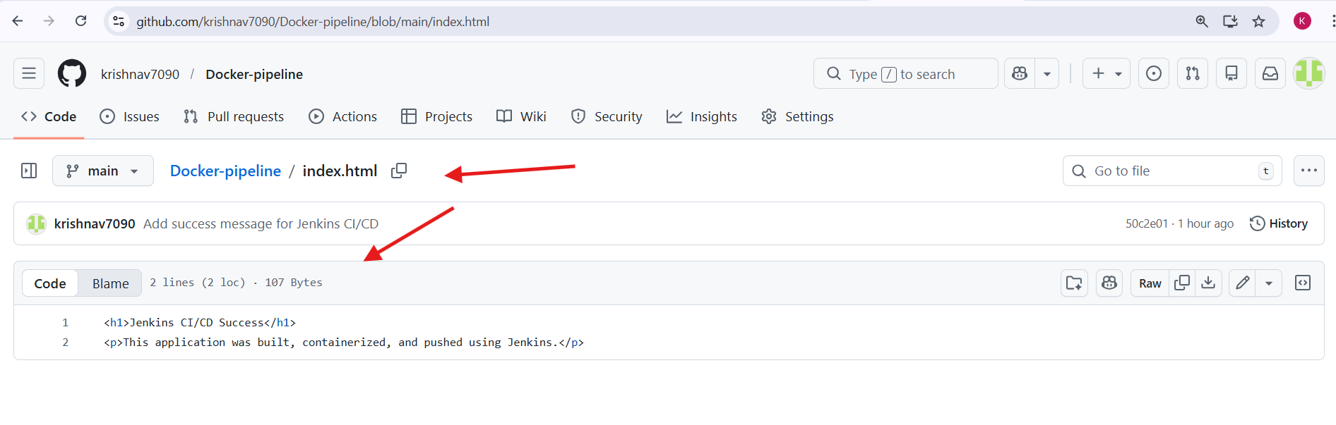
6. Jenkins Pipeline Job Creation
- Created new job:
  - Name: Dockerfile-pipeline
  - Type: Pipeline
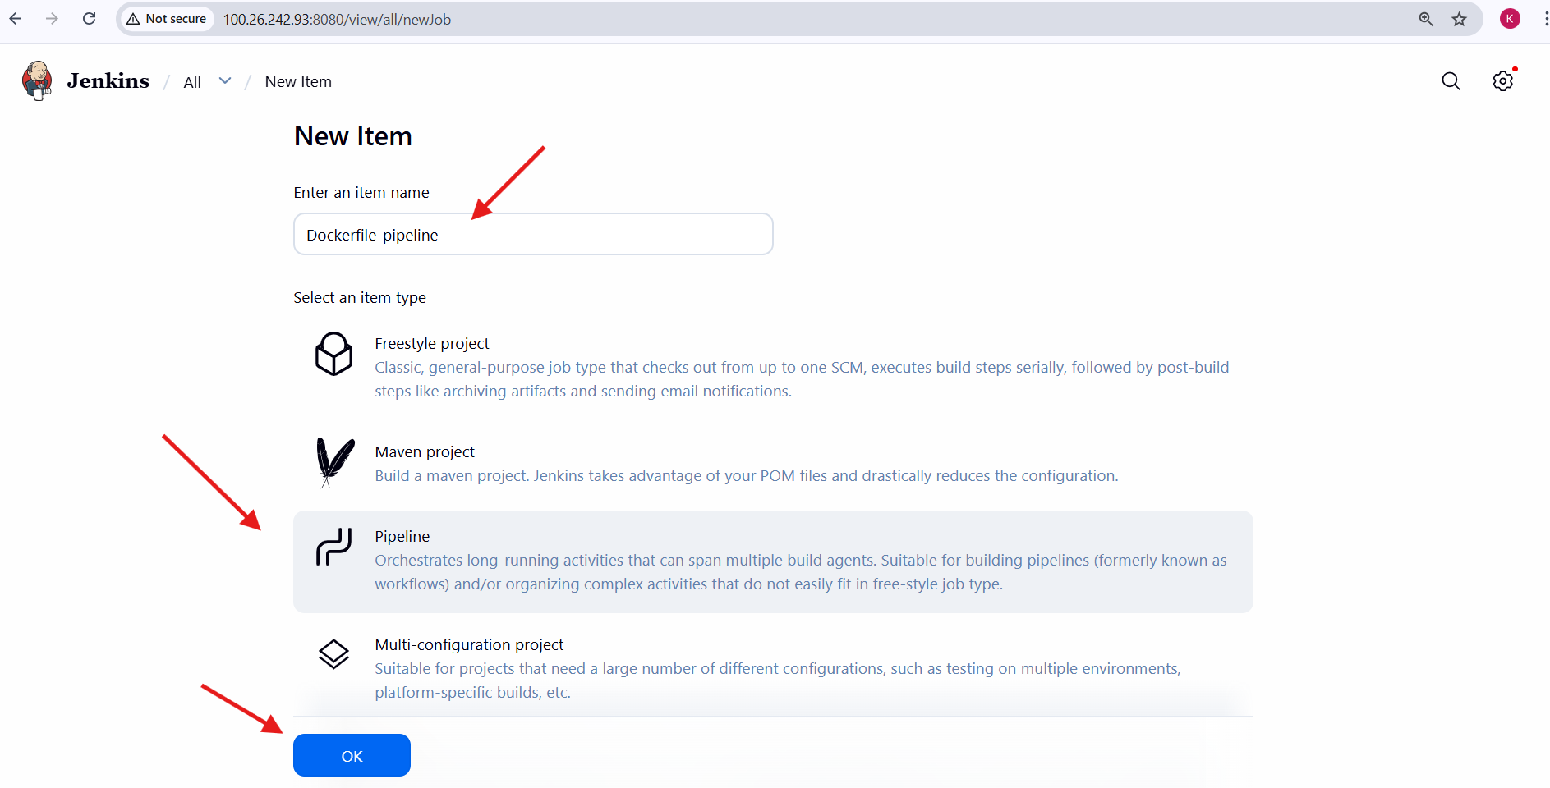
- Configured pipeline to use Git SCM
  - Repository URL:
  - https://github.com/krishnav7090/Docker-pipeline.git
  - Branch:
  - main
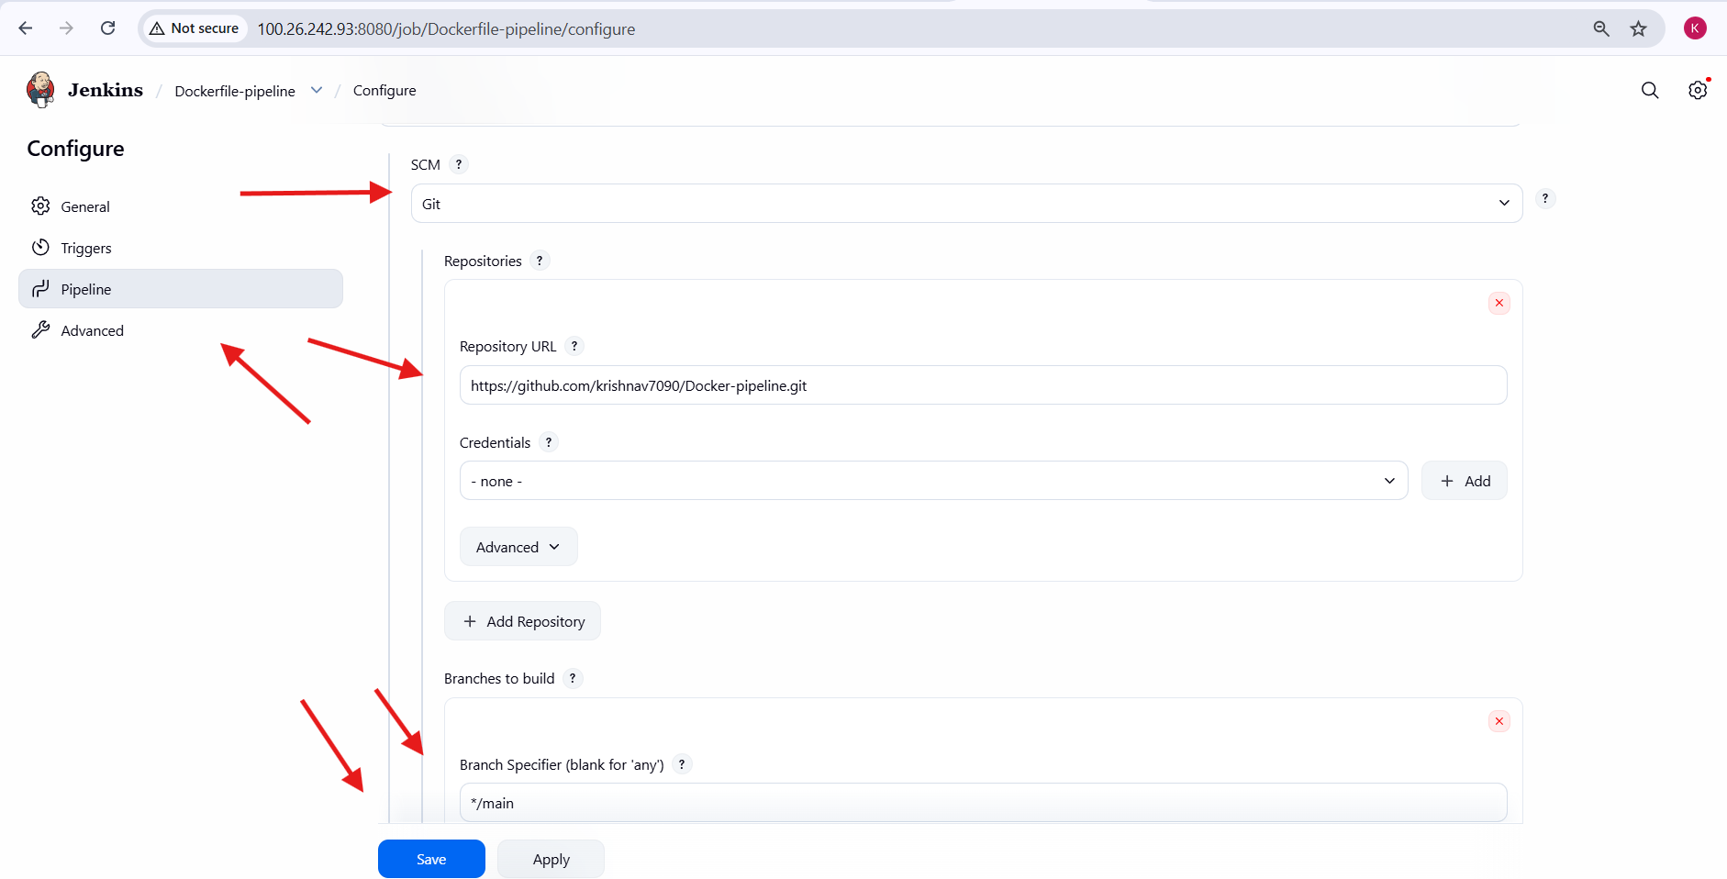
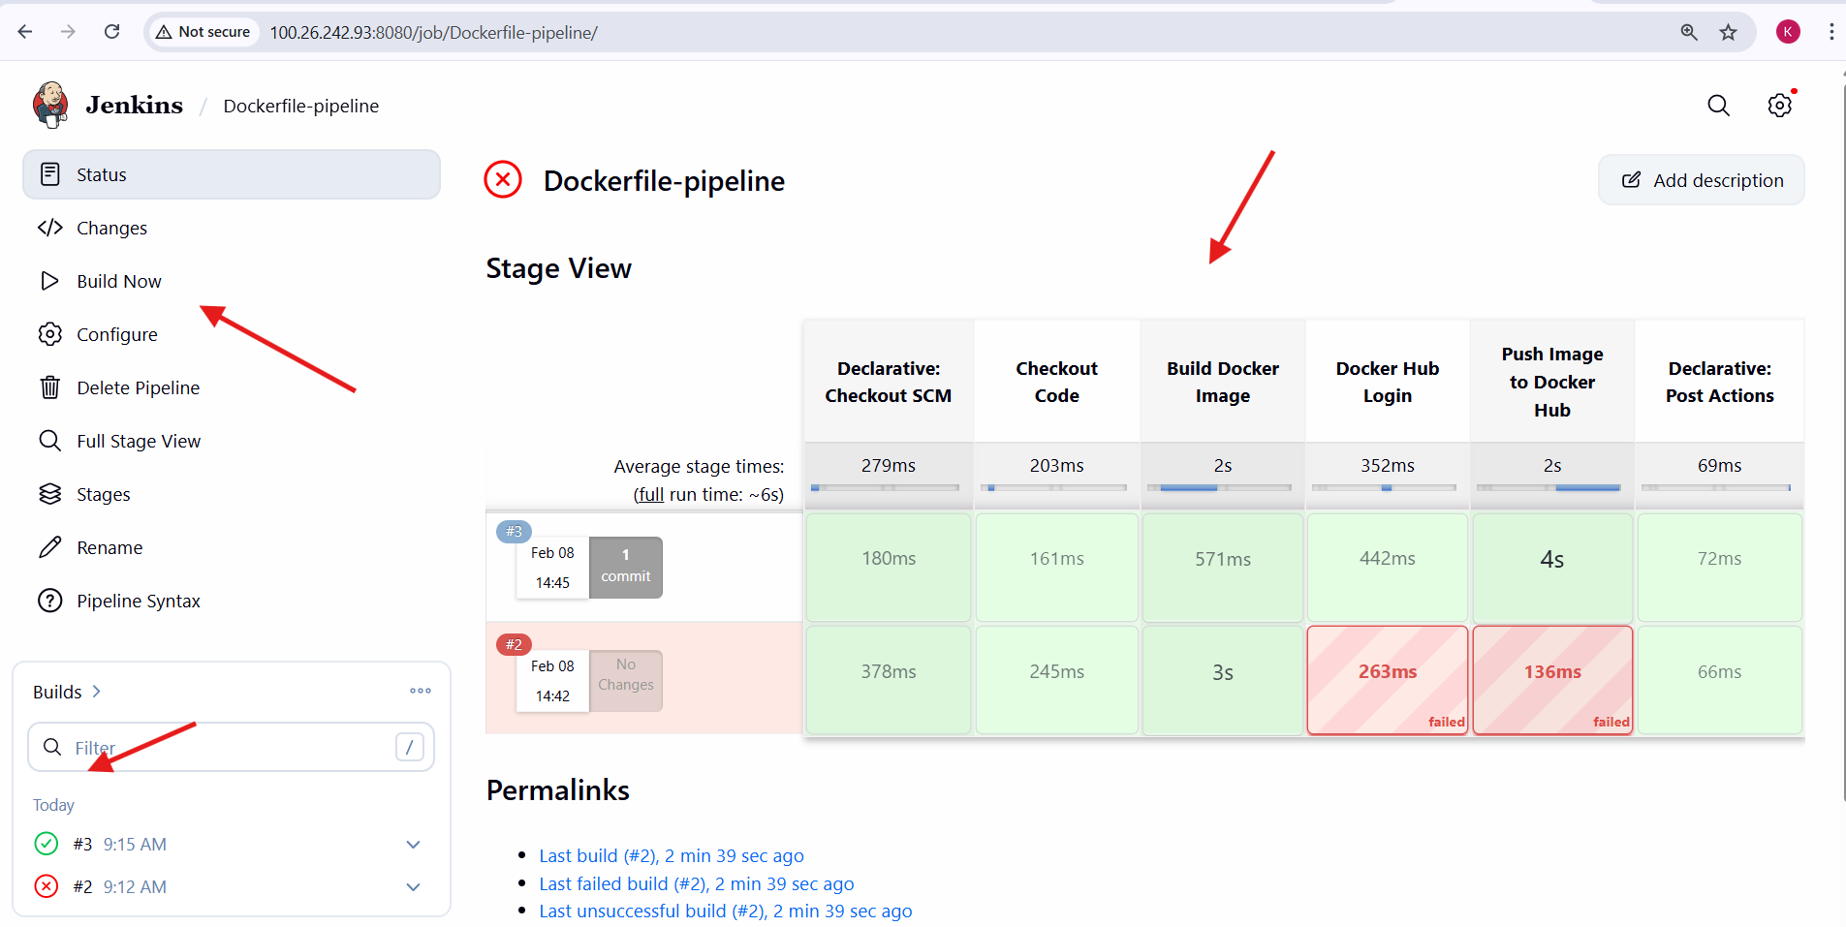

8. Issue Identified & Fix
Root Cause
- Jenkins interpreted Docker as a Groovy variable instead of a string.
Fix
withCredentials([usernamePassword(
credentialsId: 'Docker',
usernameVariable: 'DOCKER_USER',
passwordVariable: 'DOCKER_PASS'
)]) {
sh "echo $DOCKER_PASS | docker login -u $DOCKER_USER --password-stdin"
}
9. Final Outcome
- Docker image successfully built on Jenkins server
- Jenkins successfully integrated with:
  - GitHub
  - Docker Engine
  - Docker Hub (after fix)
- CI pipeline structure validated end-to-end
What is validated
- Docker image krishnav7090/myapp:v1 exists locally on your machine.
- The image was built successfully by Jenkins (as seen earlier in the pipeline logs).
- Base image nginx:latest is also present.
- Image size (~237 MB) is normal for nginx-based images.
This confirms the Build Docker Image stage worked correctly.
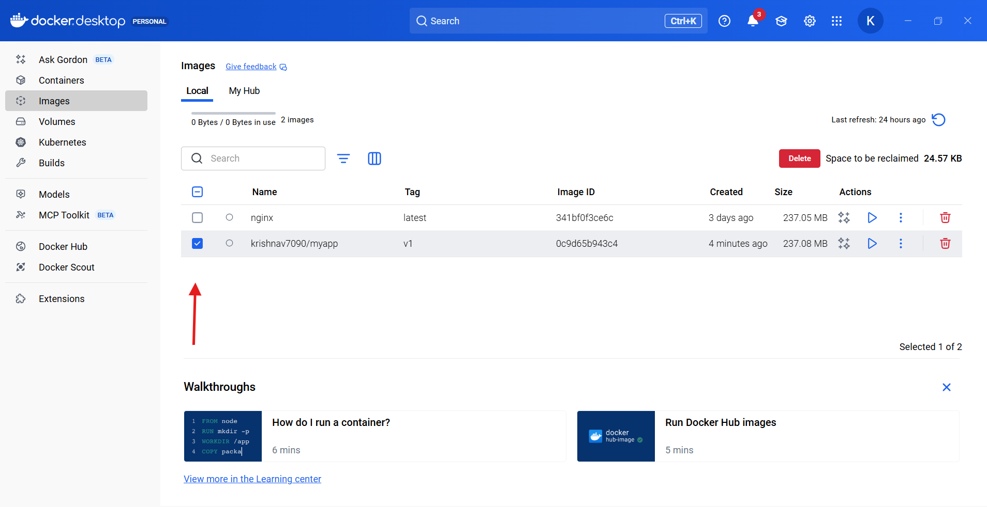

Overall Task Conclusion:
This task successfully demonstrated a complete container lifecycle workflow, from image creation and optimization to secure distribution and CI/CD automation.
Key outcomes include:
- Improved understanding of Docker image internals and optimization
- Practical exposure to Alpine-based and multi-stage Docker builds
- Hands-on experience with Docker Compose orchestration
- Implementation of container image security scanning
- End-to-end CI/CD automation using Jenkins
- Real-world troubleshooting experience involving disk usage, permissions, and service dependencies
Overall, this task provided production-level DevOps experience aligned with real industry practices, covering build efficiency, security, automation, and operational stability.

